1. **Create a private github repo and push the inde.html file to it**

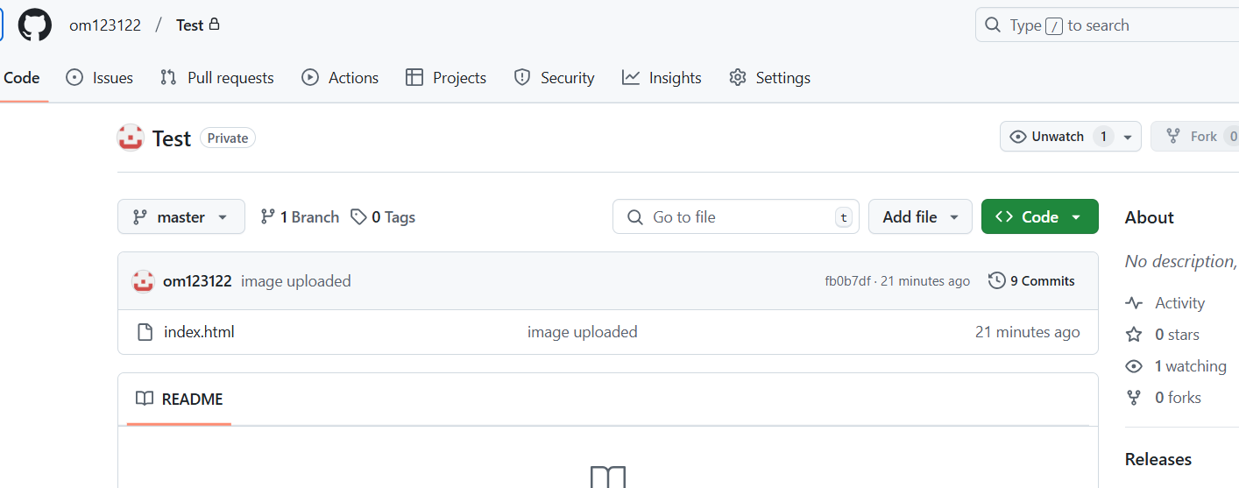

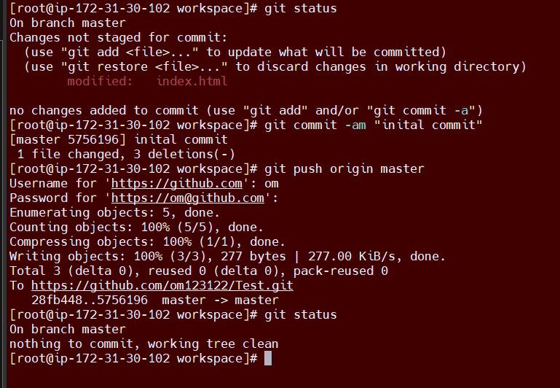

1. **Create a Jenkins job to install httpd and deploy index.html page and see the output.**

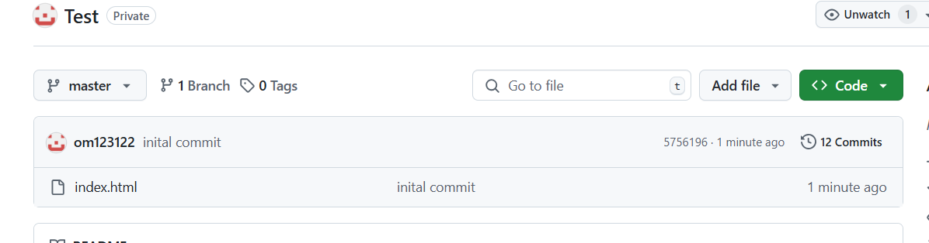

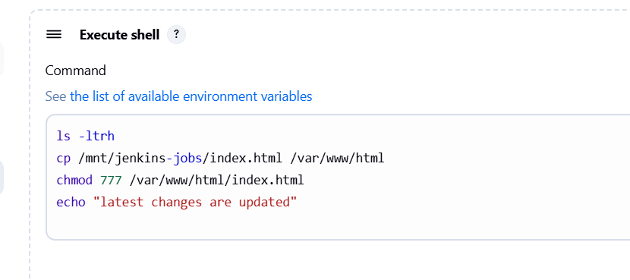

**Console output –**

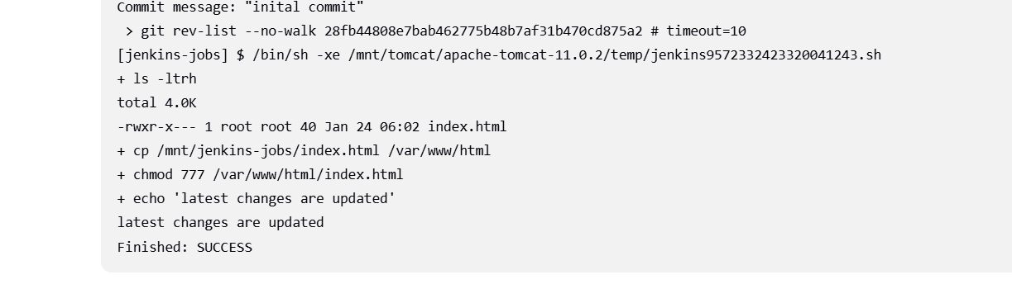

**Output –**

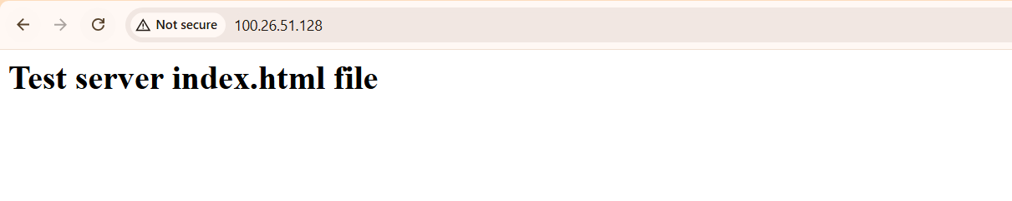

1. **Again push new changes in index.html. verify Jenkins job is deploying the new changes.**

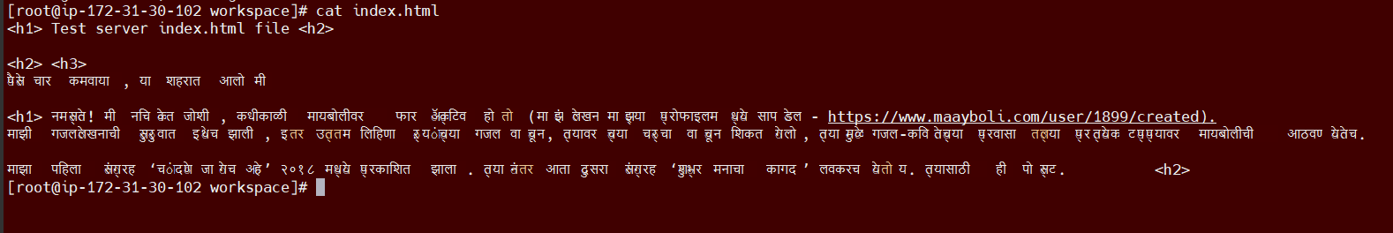

**New changes pushed-**

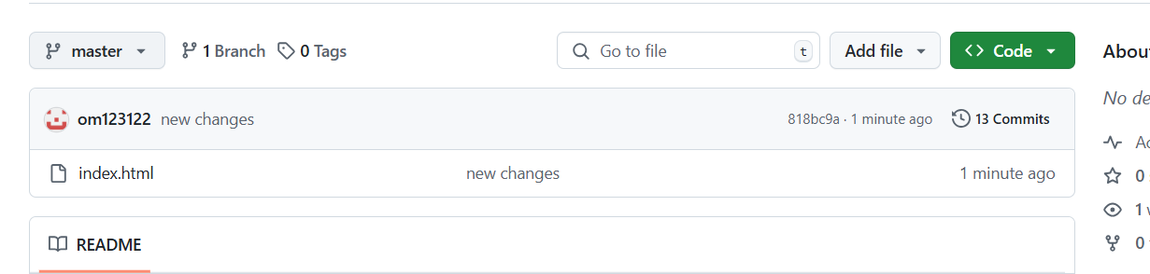

**Output – just clicked on build now**

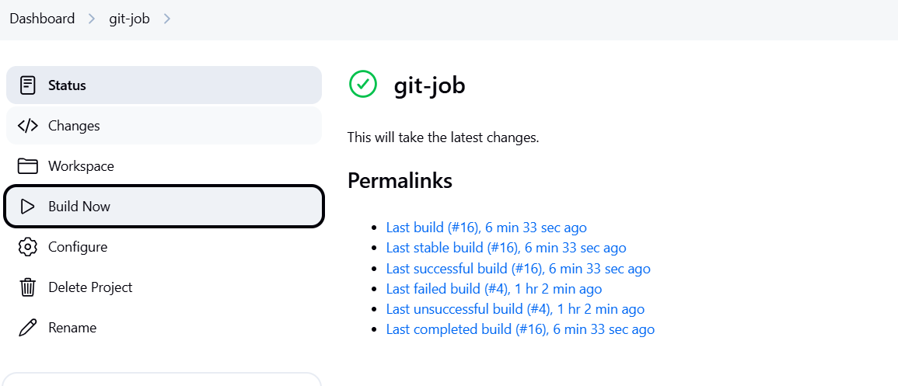

**Final output –**

